**Each week of this last term will be spent on review of learned content and the development of a final synthesis project to display the skills gained through the Independent Study. Specifically a different review subject and resource will be focused on each week (i.e. Week 1: Review of Abstract Data Types/Brainstorming, Week 2: Review of specific subcategories of data types {e.g. frozen sets, min spanning trees, digraphs et al}, Week 3: ComSci Core Principles, Week 4: Algorithm *Types*, Week 5: Algorithm *Analysis* {comp.complexity, analysis of loops/recursion, etc}, Week 6: Content/Vocabulary/Problem Solving quizzes online). Additionally, time will be devoted each week to continuing work on the final project (subsequent to a week of brainstorming).**

|  |  |  |  |  |  |
| --- | --- | --- | --- | --- | --- |
| **Week 1** | **Week 2** | **Week 3** | **Week 4** | **Week 5** | **Week 6** |
| Brainstorming Synthesis Project  Review of data types (primitive, abstract, data structures) | Deciding on Project Idea | Continued adding specific types of information and methods that would be useful in a D&D situation | Review of Algorithms  Implemented graphs and trees into synthesis project | Review of computational complexity, recursion, etc | Finished and presented Synthesis Project for grade. Concluded Independent Study |
| **Weekly Assignment 1** | **Weekly Assignment 2** | **Weekly Assignment 3** | **Weekly Assignment 4** | **Weekly Assignment 5** | **Weekly Assignment 6** |
| Single page paper, brainstorming possible project ideas  Quizlet Data Type Study Set/Review of Terms  <https://quizlet.com/_3e9f4k> | Continuation of Data Type Review  Quizlet Study Set on the Applications of data structures and algorithms in the networking industry <https://quizlet.com/_3eqpfu> | Review of core computer science concepts on Quizlet  <https://quizlet.com/_3gpxz9> | Review of popular algorithms used in computer science and problem solving  <https://quizlet.com/_3hpoxg> | Review of ways to analyse algorithms, information added to previous quizlet set (“Algorithms”) | Upload remaining assignments, notes, curriculum, journals, and all other remaining materials to Github. |

**Week 1:**

**Day 1:**

**▶** Organized curriculum plan for the final 6 week term (In Google Drive {“Independent Study Progress Report,” this document} and Github)

**▶** Starting typing list of brainstorming proposals for final synthesis project

**Day 2:**

**▶**  Began reviewing notes on data types and compiling information into a Quizlet study set of terms (Consider creating all all-encompassing test at the end of this term to act as review or as a final test to accompany the synthesis project)

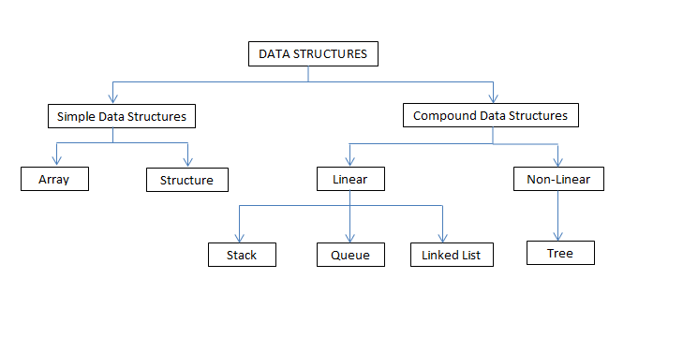

**Week 2:**

**Day 1:**

**▶**  Continued studying data types, with a focus on specific implementations and their performance complexities/real world applications rather than broad abstract organization of data

**▶** Created second Quizlet study set on the real world applications of different data structures (i.e. what each data type is used for in computing, etc)

**Day 2:**

**▶** Completed analysis of brainstorming project proposals, decided on option 3 (proposal document found in *Assignments/Completed/Term 3*)

**▶**  Registration for BSU’s “Dual Credit Computer Science Principles A” for the Fall of 2017

Dual Credit Computer Science Principles A (BSU) This course covers the central ideas of computer science using visualization and application. Students will learn the ideas and practices of computational thinking with a focus on fostering student creativity. They will develop a range of skills by using computational tools to analyze and study data, work individually and collaboratively to solve problems, and discuss the importance of problems and the impacts to their community, society and the world. This course is designed to be far more than a traditional introduction to programming. It is a rigorous, engaging, and approachable course that explores many of the big, foundational ideas of computing so that all students understand how these concepts are transforming the world we live in. This is the first semester of a year-long course and continues with AP Computer Science Principles B. Prerequisites: Algebra I Textbooks and resources: Optional: Blown to Bits: Your Life, Liberty, and Happiness After the Digital Explosion 1st Edition by Hal Abelson, Ken Ledeen, Harry Lewis – (Purchase hard copy or download free digital version)

**Day 3:**

**▶**  Took Health Final Exam during first half of class period due to scheduling conflicts (AP Exams)

▶ Scanned notes from Term 2 (at home) then uploaded files to Google drive and Github and organized them into the notes folders for easy access and future reference

▶ Worked on synthesis project (Dungeons and Dragons data storage and manipulation tool) and completed the Character class, a few methods (for changing, initializing a few basic values such as random character statistics, inventory, etc.), membership variables (e.g. see previous parenthesis). Mostly using primitive data types (such as characters, lists, integers, etc), but also uses set for inventory (as it avoids repeats of values, so as to avoid cheating/confusion by stocking up on many of a particular item) as well as a dictionary or hashmap for the players stats (i.e. charisma, intelligence, dexterity, constitution, wisdom, strength), as well as a working list of characters playing in a campaign (team count is increased at the initialization of a player (each human player uses the same base class). The next step is to make other classes which inherit from the Player class which represent different “classes” or “races’ <https://en.wikipedia.org/wiki/Character_class_(Dungeons_%26_Dragons)> OR I might consider making a map class, which would demostrate a greater variety of unique data structures such as linked lists, graphs, and trees.

**▶** Next steps:

1) Create a world or dungeon map using a graph (nodes/locations connected by edges with weights that represent distance and expended energy when crossing)...

2) A collection of quests using a tree (that way, even though there is still an order to which quests you can complete first, the players are still given a CYOA-esque choice)...

3. Linked list (potentially a queue) of different bosses or NPC (nonplayer characters) that you can create in a specific order that reflects leveling up (you may only reach the next one by going through the previous one)...

4. A history of the most recent boss, town, etc you have encountered using a stack

**Week 3:**

**Day 1:**

**▶**  Made quizlet set of core computer science concepts review

**Day 2:**

**▶**  Played around with Edison robots (ed.py programming library)

**Day 3:**

**▶**  Continued development of synthesis project following the aforementioned goals from the previous week

**Week 4:**

**Day 1:**

**▶**  Made quizlet set of different algorithm types and specific algorithms to know

**▶** Will add a comparison of different sorting algorithms (because they are quintessential when describing algorithm complexity, variation, etc) then add some more examples of algorithms (HOMEWORK ASSIGNMENT FOR 4 DAY WEEKEND)

**Day 2:**

**▶**  Finished Quizlet set regarding algorithms (lots of search/sorting algorithm analysis and comparison)

**▶ Will set goal of completing synthesis project over 4 day weekend!**

**Week 5:**

**Day 1:**

**▶**  Added computational complexity theory, recursion, and other algorithm CONCEPTS and means of analysis to Quizlet set.

**▶ Continued synth project work**

**▶** Building a text based user interface to navigate program more abstractly

**▶** Adding ASCII graphics to aid understanding of program’s commands

**▶** Defining a help() function that lists commands alphabetically with a short description of what each one does (essentially a menu or directory)

**Day 2:**

**▶**  Continued to define the text-based UI in order to store data more abstractly for the user (mainly adding to the help reference function)

**▶** Solving issues with the conversion of a single tuple parameter into a dictionary for the implementation of a graph for the map class

**Week 6:**

**Day 1:**

**▶**  Player construction (and all related interface, method, global variable storage stuff) COMPLETED

**▶**  FINISHED all map related aspects of program, including printing suggestions of map-relevant methods or functions to call after map construction, to give user some specific direction outside of broader help function

**▶** Completely finished help() function and other additionally commands. The last thing to do is to figure out a way to format the quest tree in a way that is intuitive and comprehensible to the user when a campaign is printed [see __str__ in Quest() class on line 539 in current code]

**Day 2:**

**▶**  Finalized and presented synthesis project